**IAM AWS - Create a User**

**Objectives**

As you probably know at this point, it's not recommended to work with the root account in AWS. For this reason you are going to create a new account which you'll use regularly as the admin account.

1. Create a user with password credentials
2. Add the newly created user to a group called "admin" and attach to it the policy called "Administrator Access"
3. Make sure the user has a tag called with the key Role and the value DevOps.

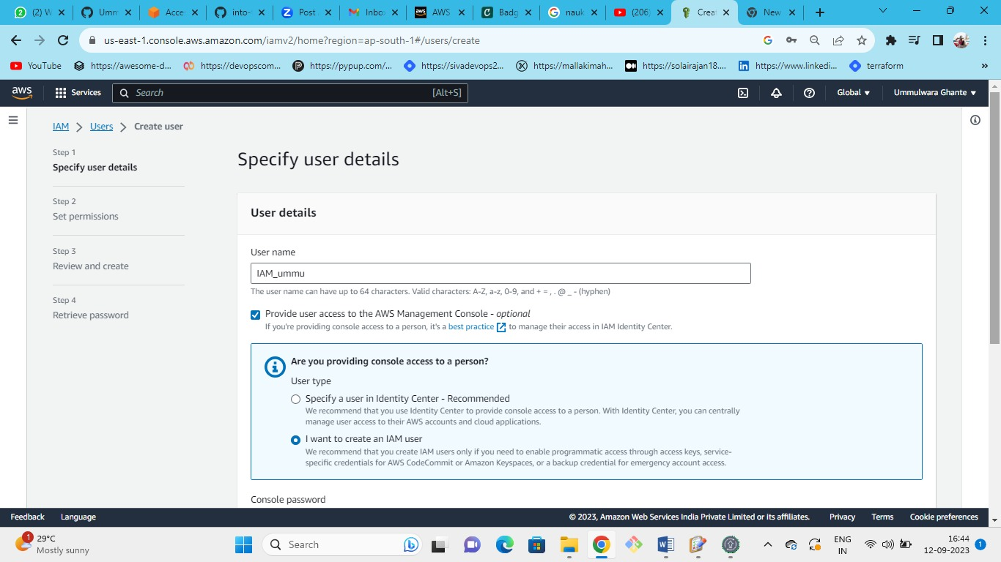

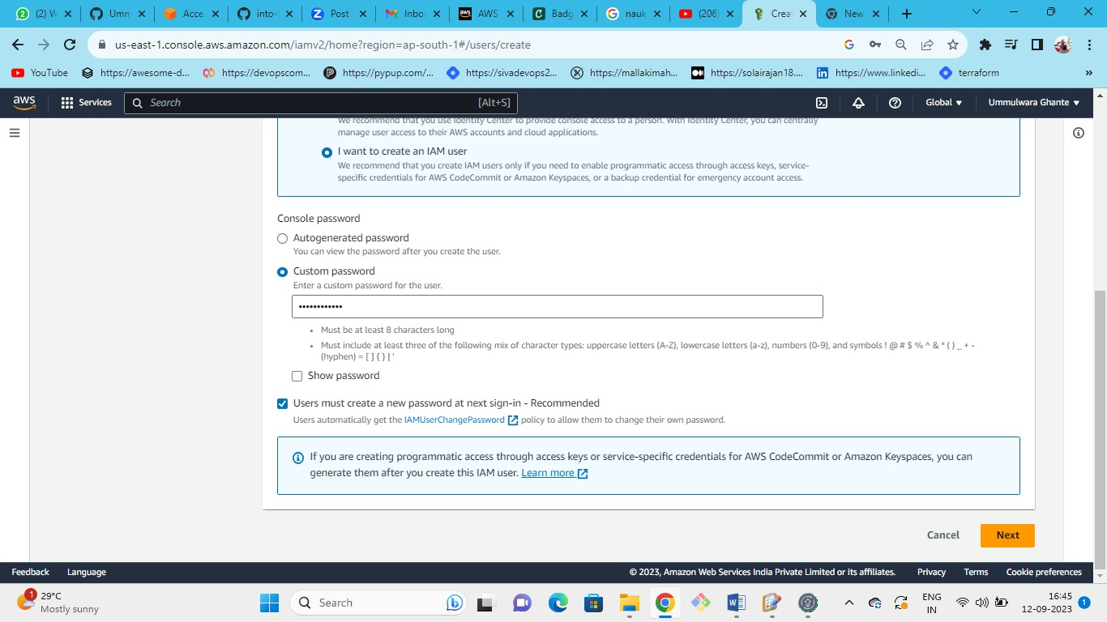

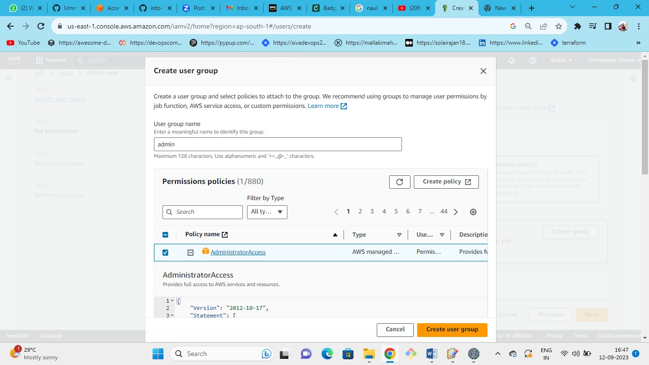

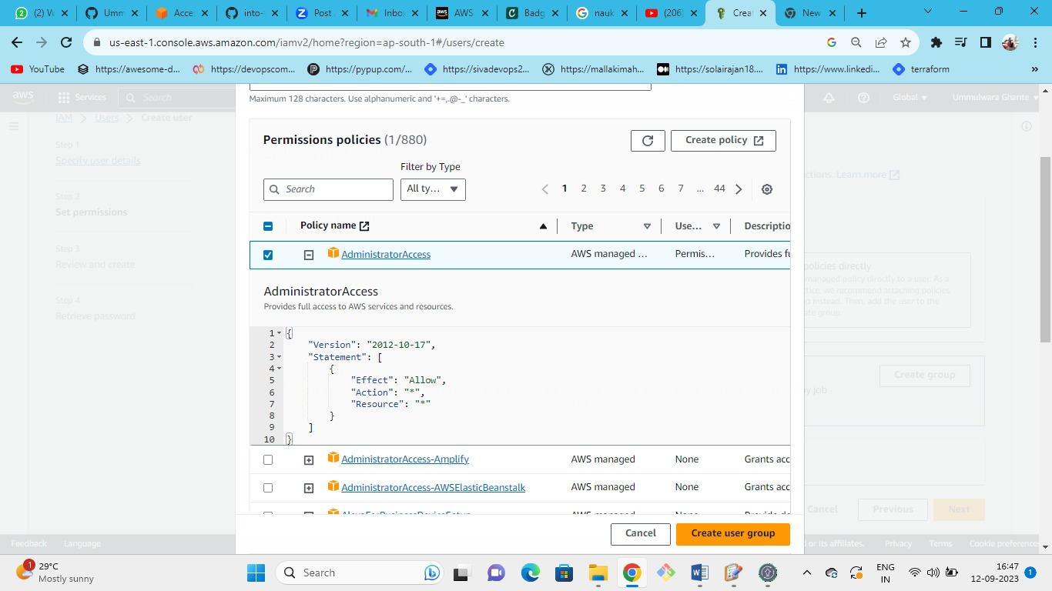

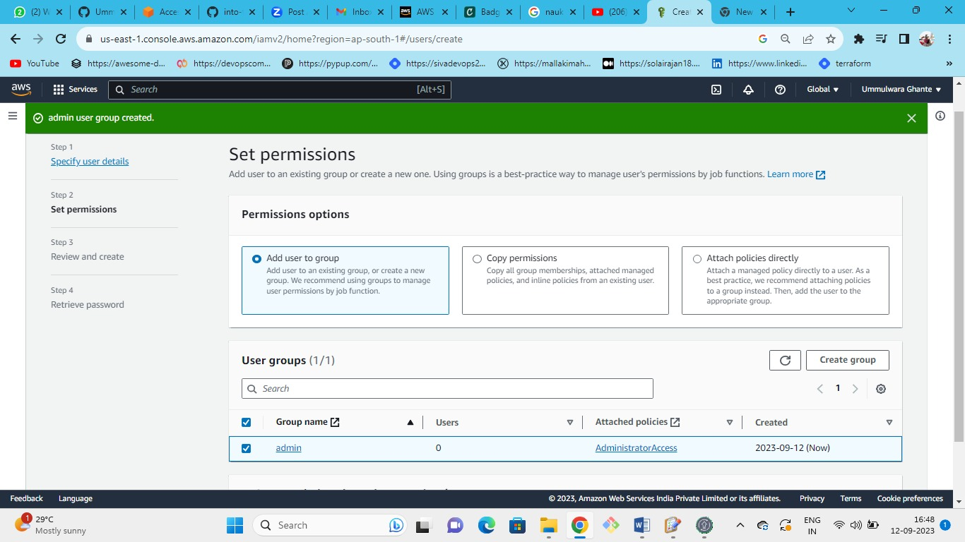

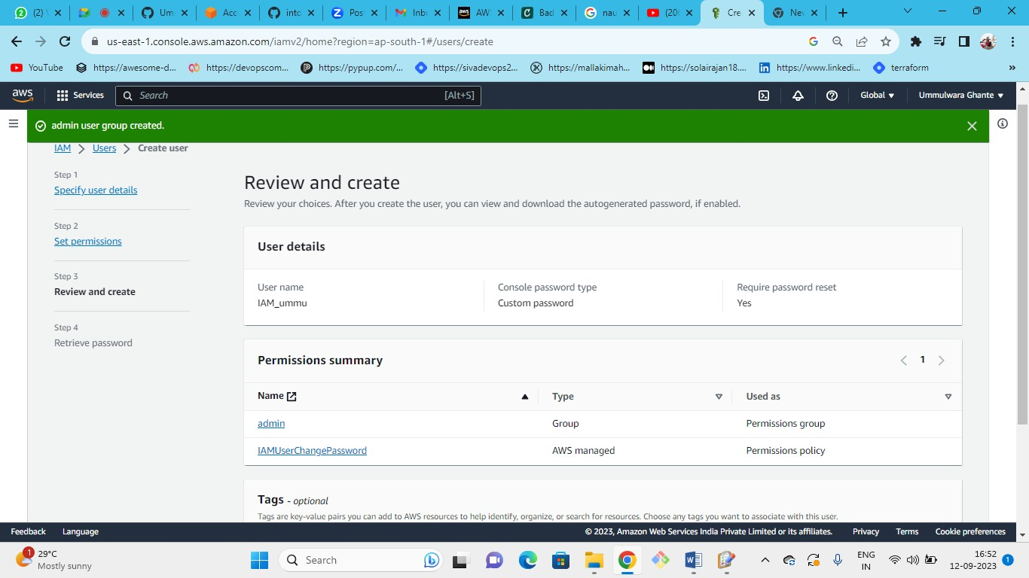

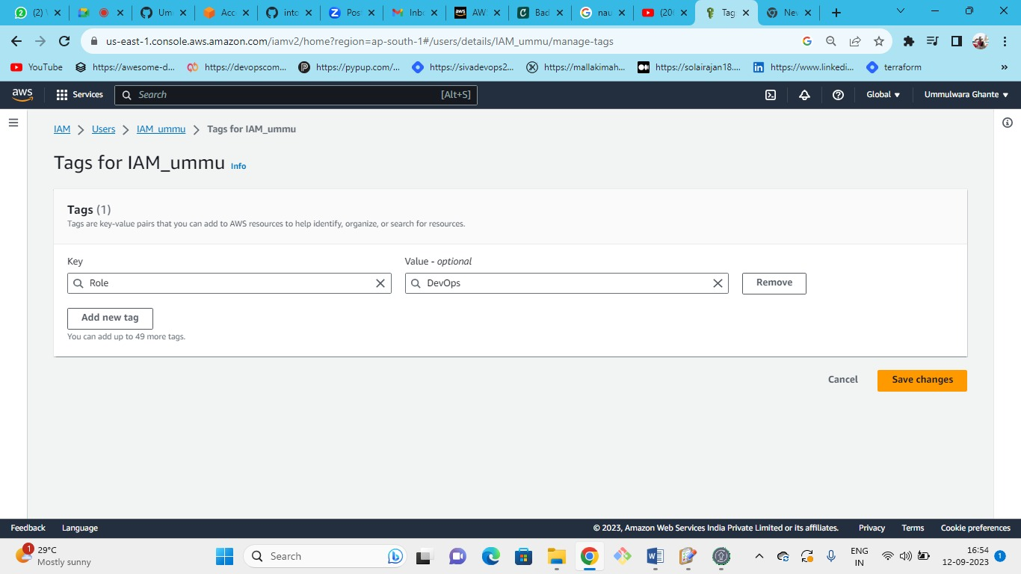

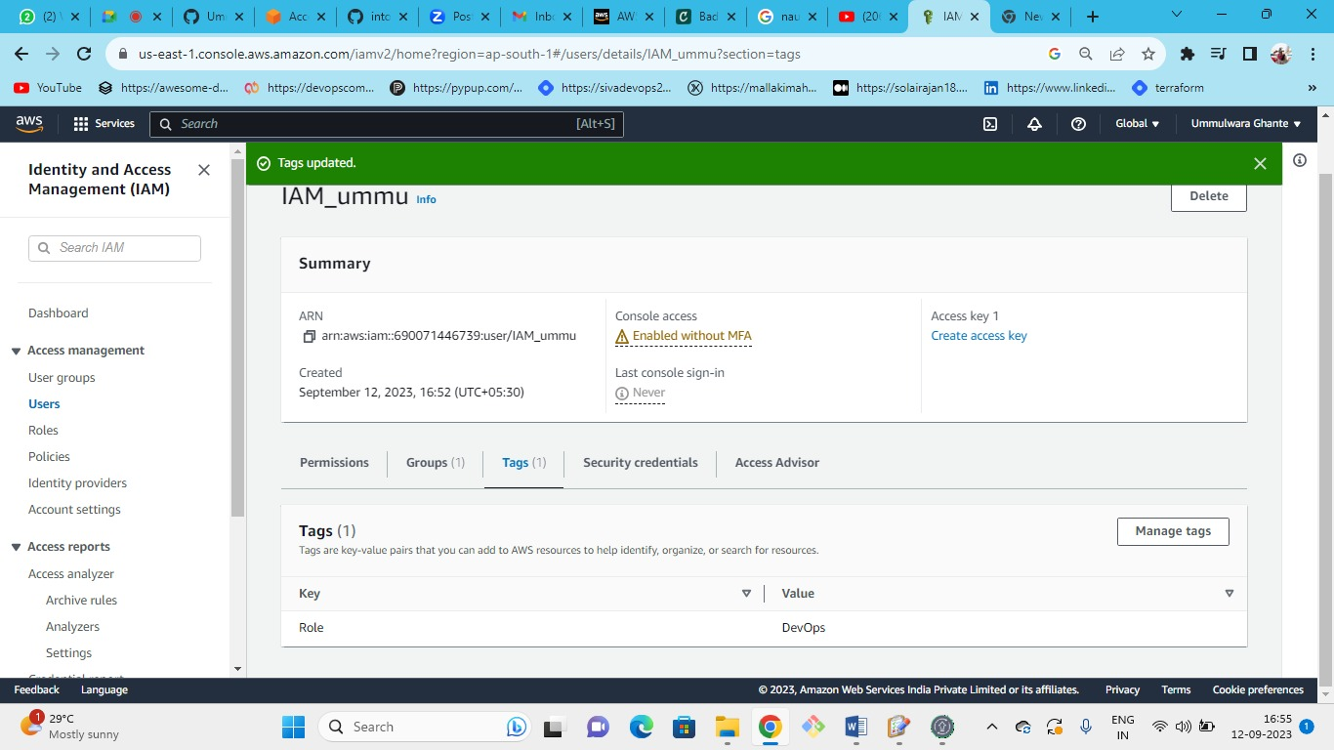

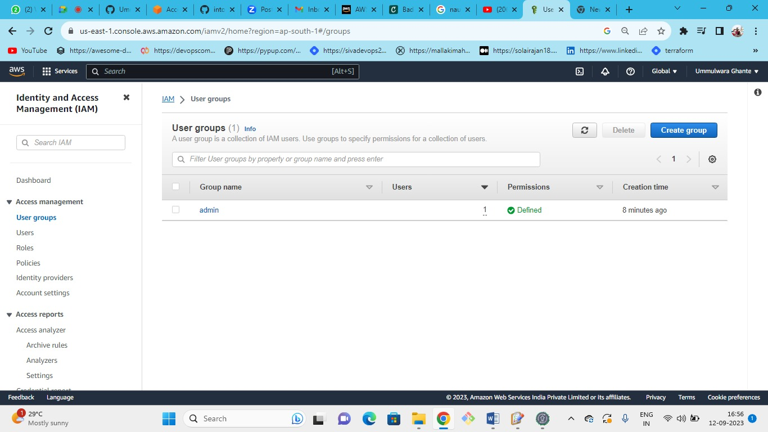

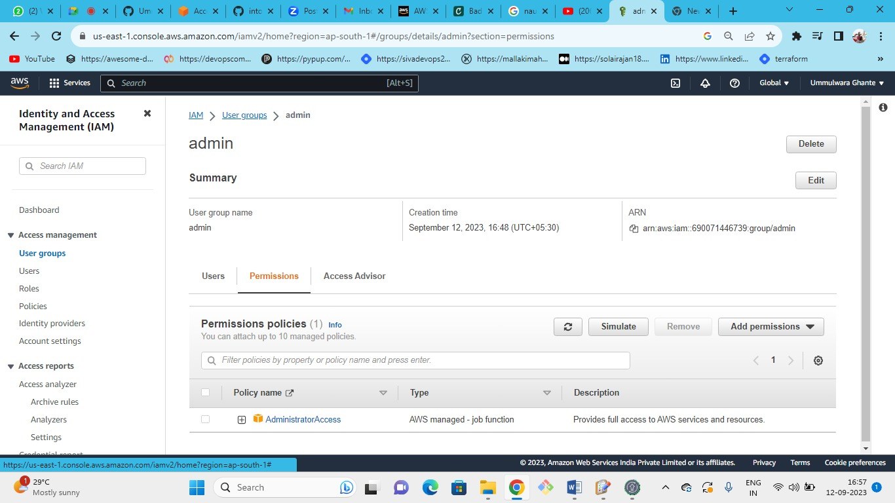

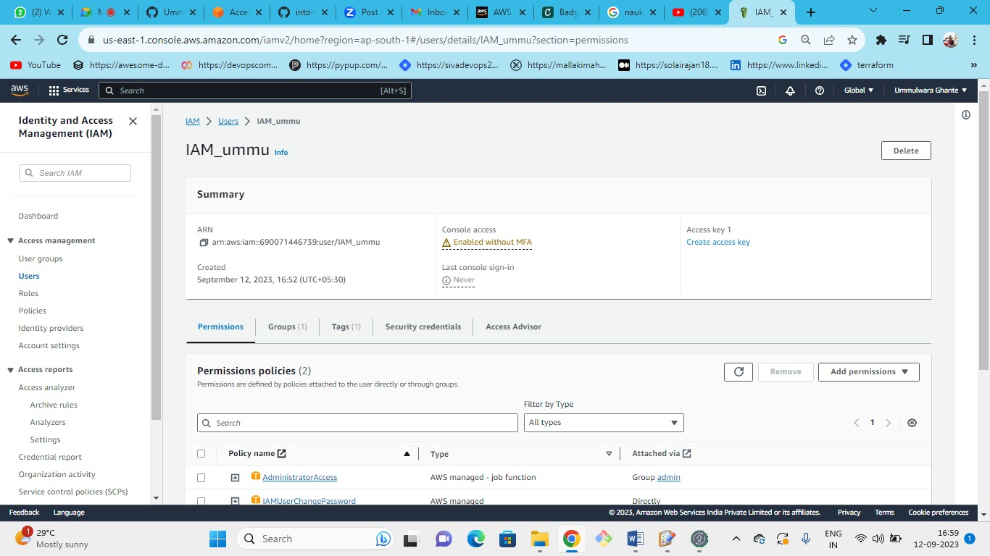

**Solution**

1. Go to the AWS IAM service
2. Click on "Users" in the right side menu (right under "Access Management")
3. Click on the button "Add users"
4. Insert the user name (e.g. Mario)
5. Select the credential type: "Password"
6. Set console password to custom and click on "Next"
7. Click on "Add user to group"
8. Insert "admin" as group name
9. Check the "Administrator Access" policy and click on "Create group"
10. Click on "Next: Tags"
11. Add a tag with the key Role and the value DevOps
12. Click on "Review" and then create on "Create user"

## AWS IAM - Password Policy & MFA

### Objectives

1. Create password policy with the following settings:
2. At least minimum 8 characters
3. At least one number
4. Prevent password reuse
5. Then enable MFA for the account.

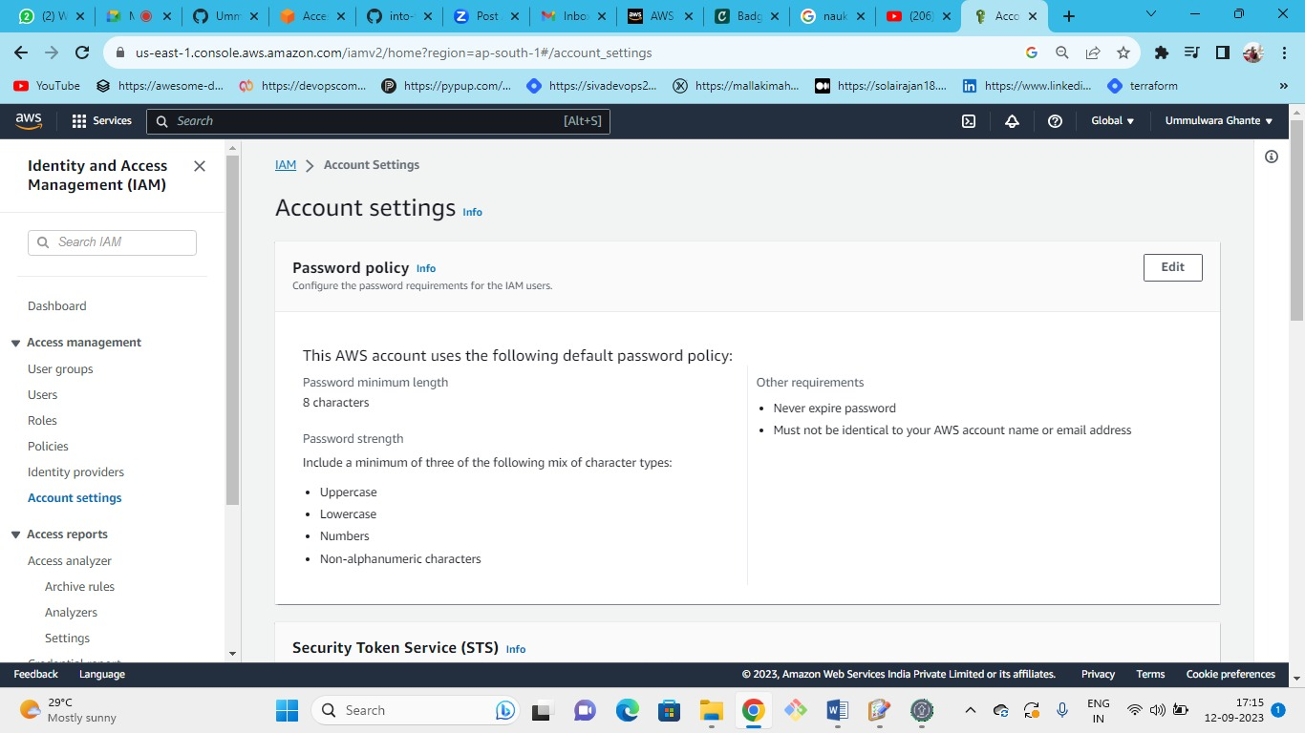

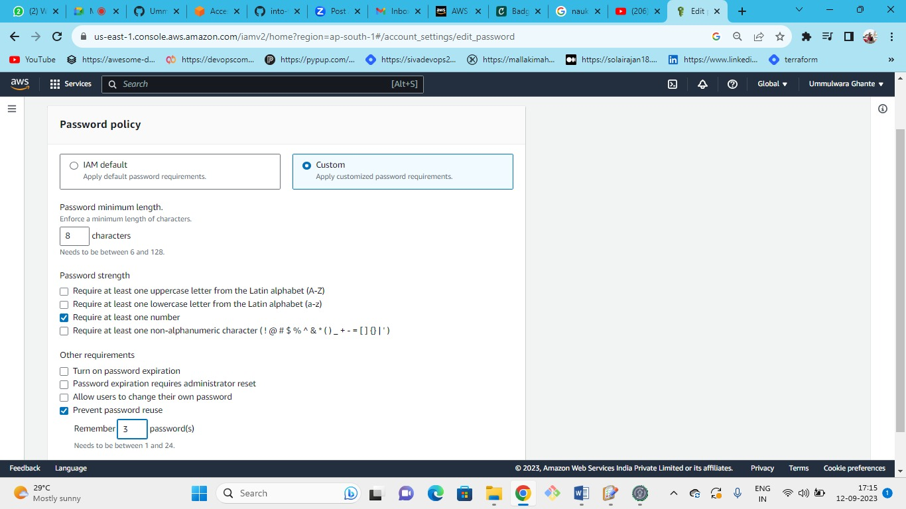

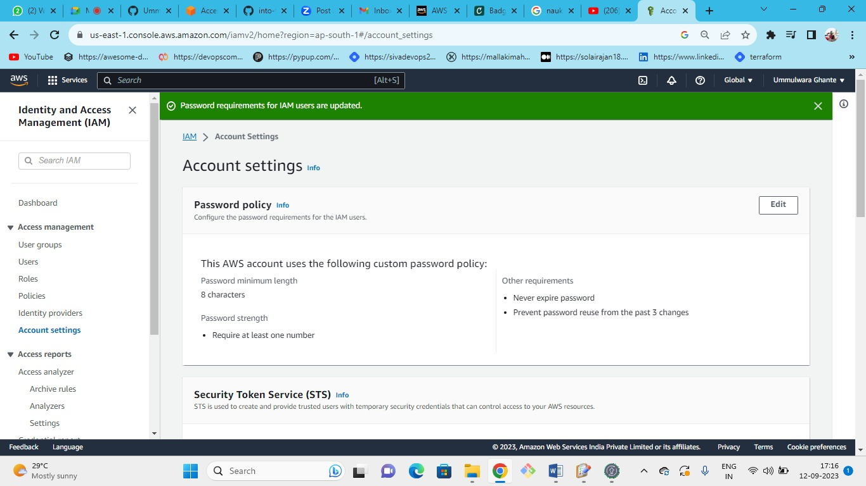

**For Multi-Factor Authentication**

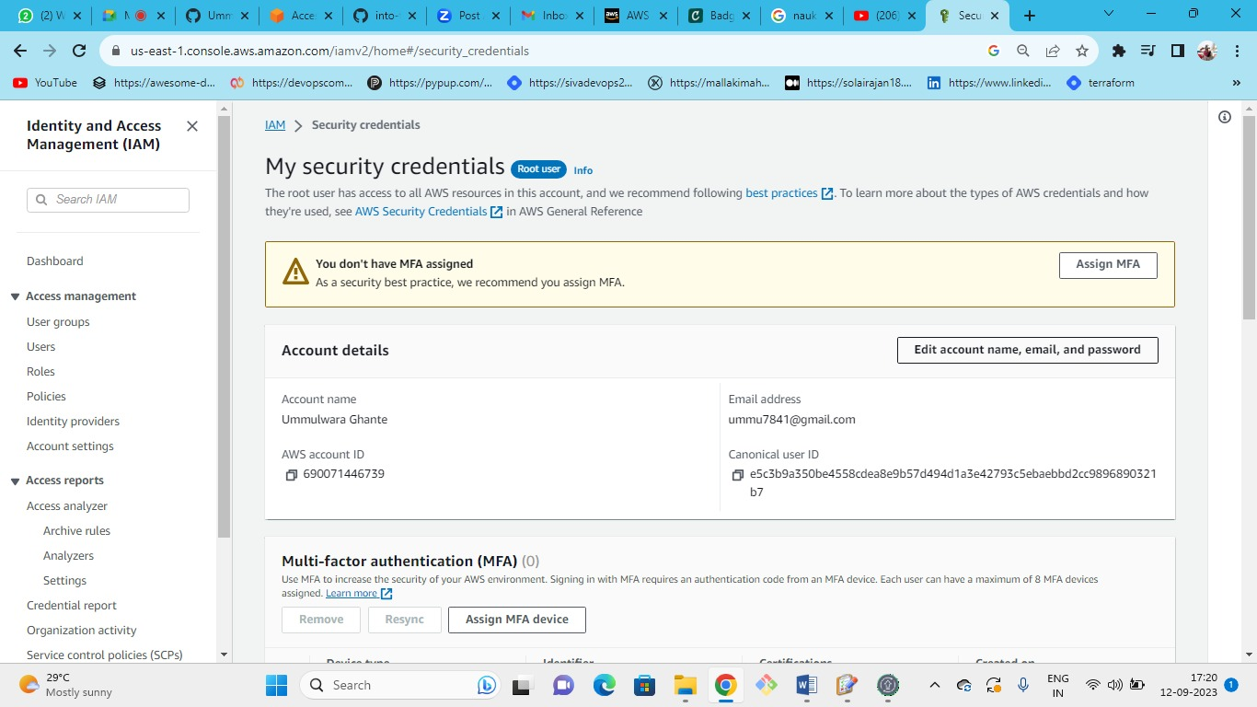



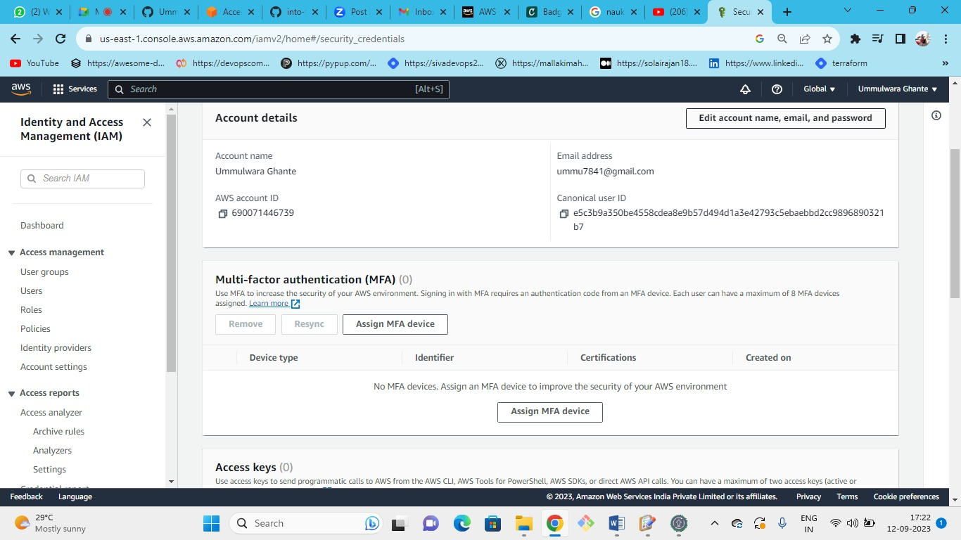



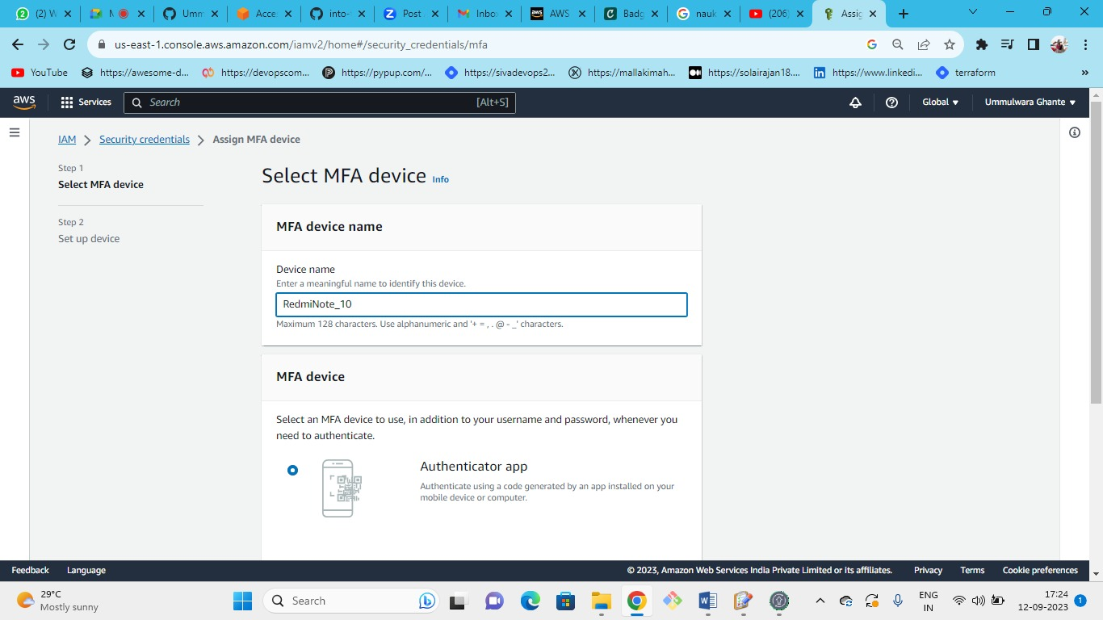

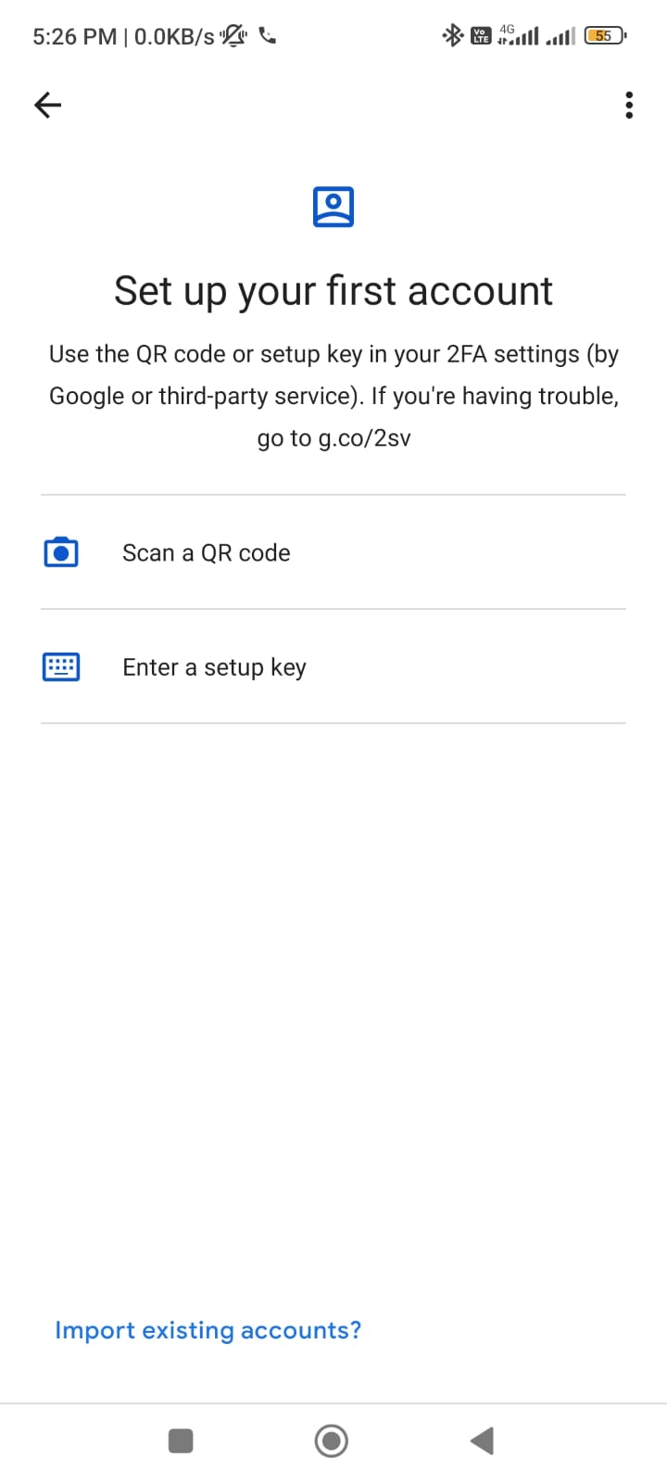

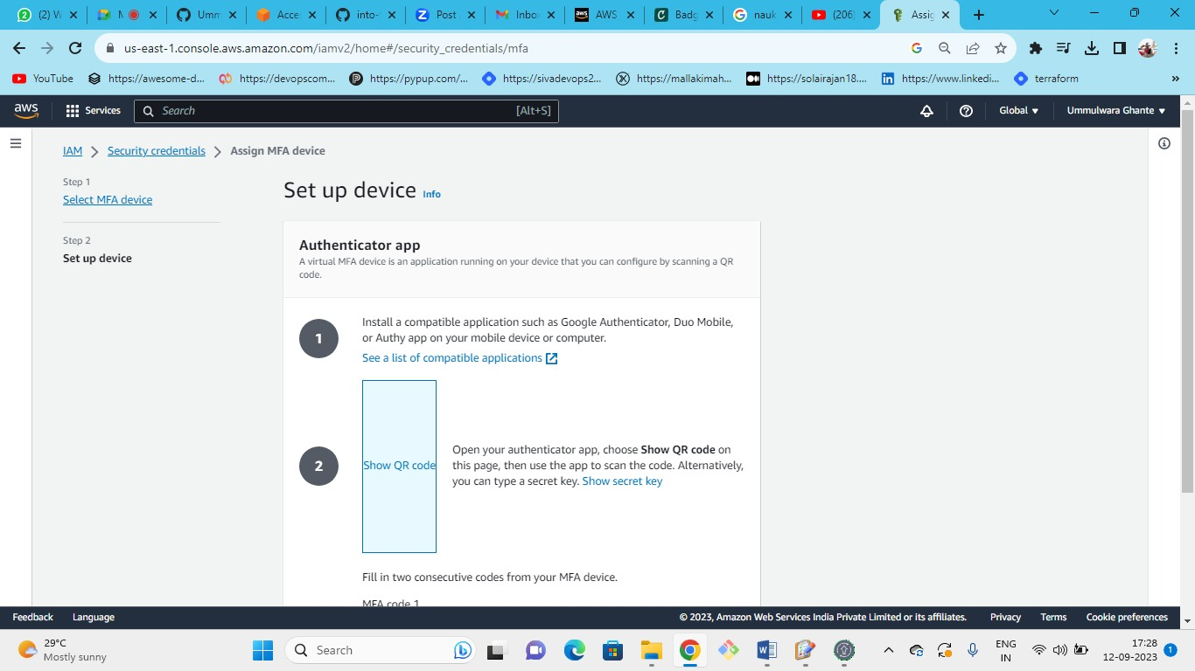

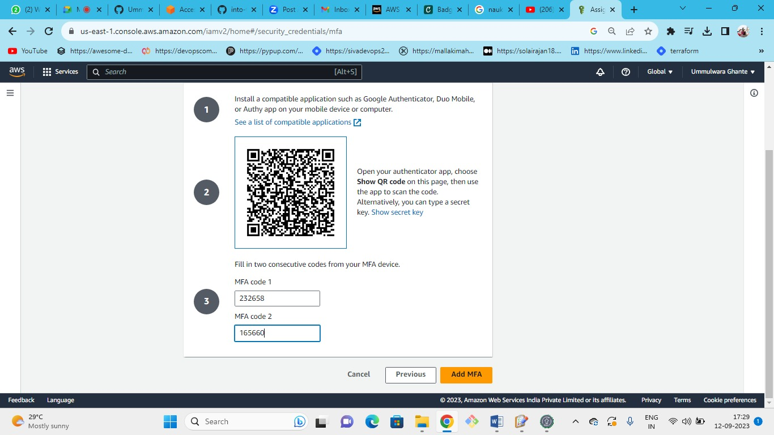

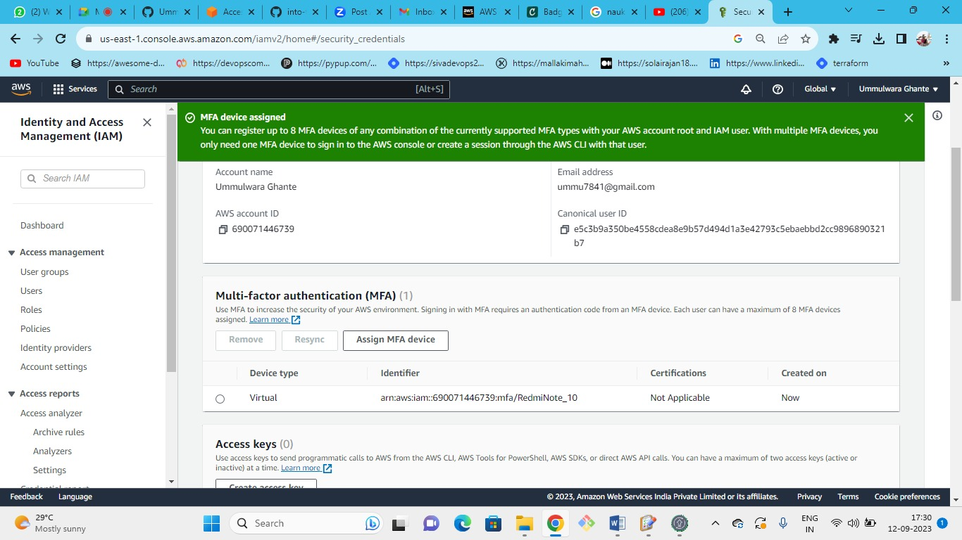

**Solution**

Password Policy:

1. Go to IAM service in AWS
2. Click on "Account settings" under "Access management"
3. Click on "Change password policy"
4. Check "Enforce minimum password length" and set it to 8 characters
5. Check "Require at least one number"
6. Check "Prevent password reuse"
7. Click on "Save changes"

MFA:

1. Click on the account name
2. Click on "My Security Credentials"
3. Expand "Multi-factor authentication (MFA)" and click on "Activate MFA"
4. Choose one of the devices
5. Follow the instructions to set it up and click on "Assign MFA"

## AWS - Create a Role

**Objectives**

Create a basic role to provide EC2 service with Full IAM access permissions.  
In the end, run from the CLI (or Cloud Shell) the command to verify the role was created.

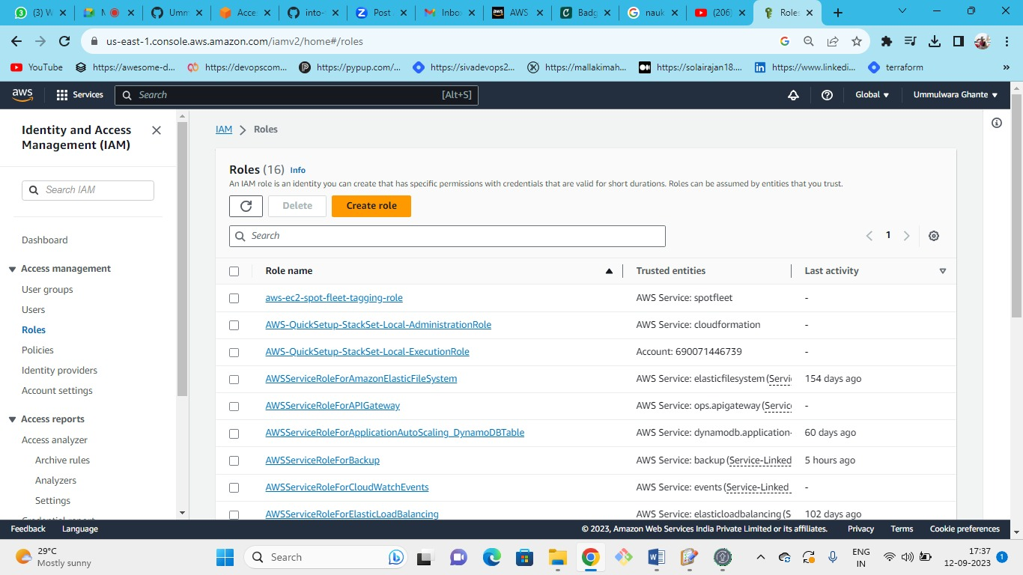

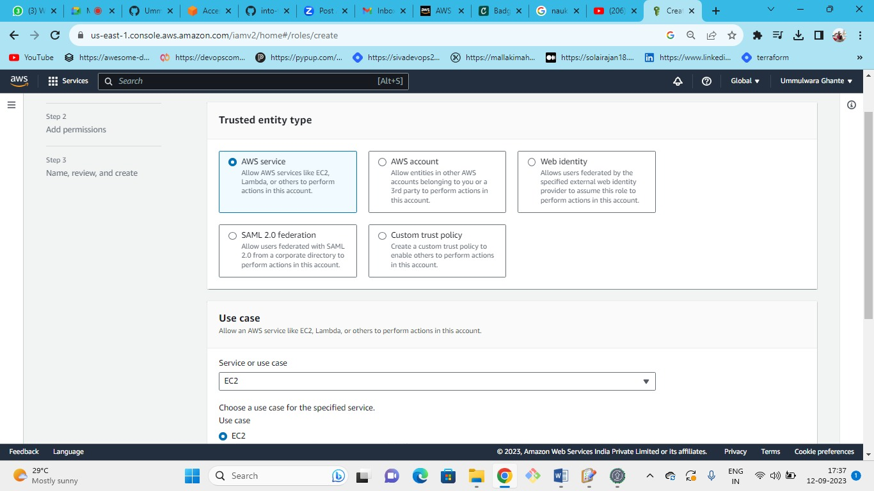

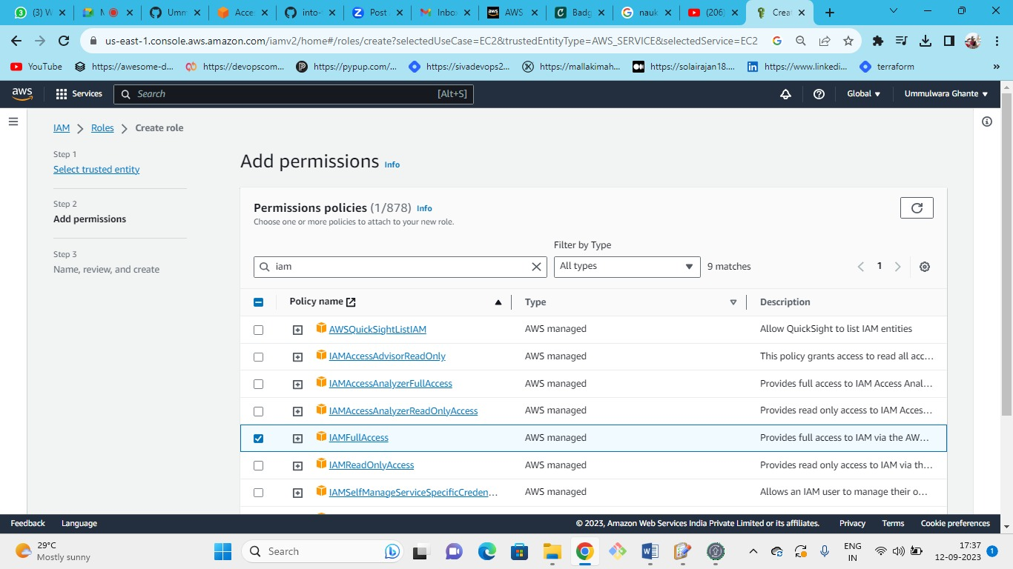

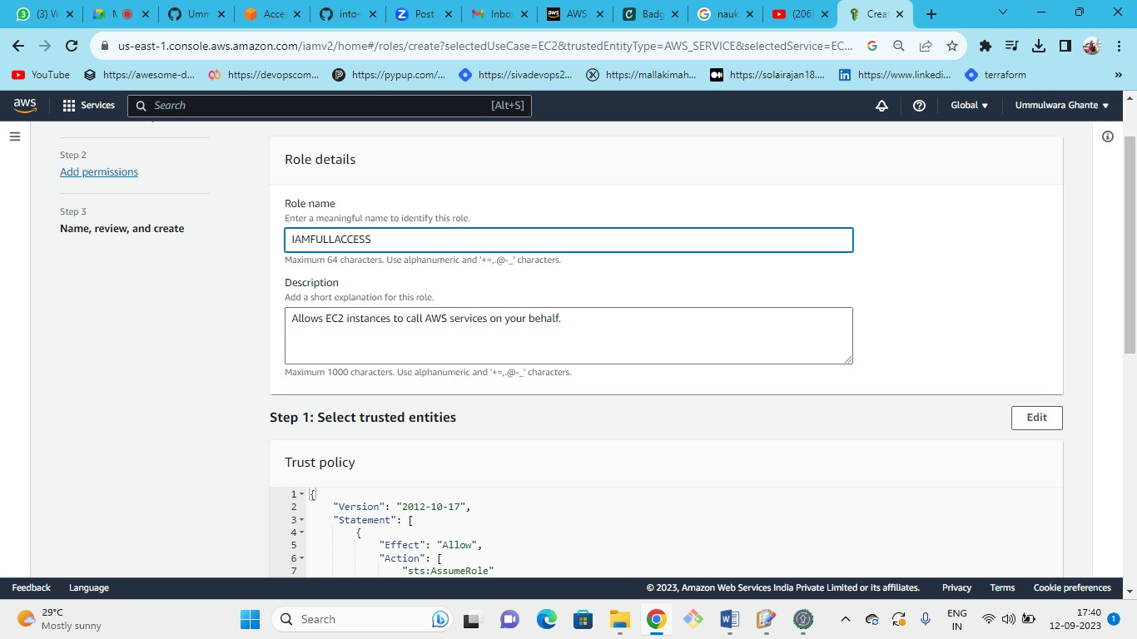

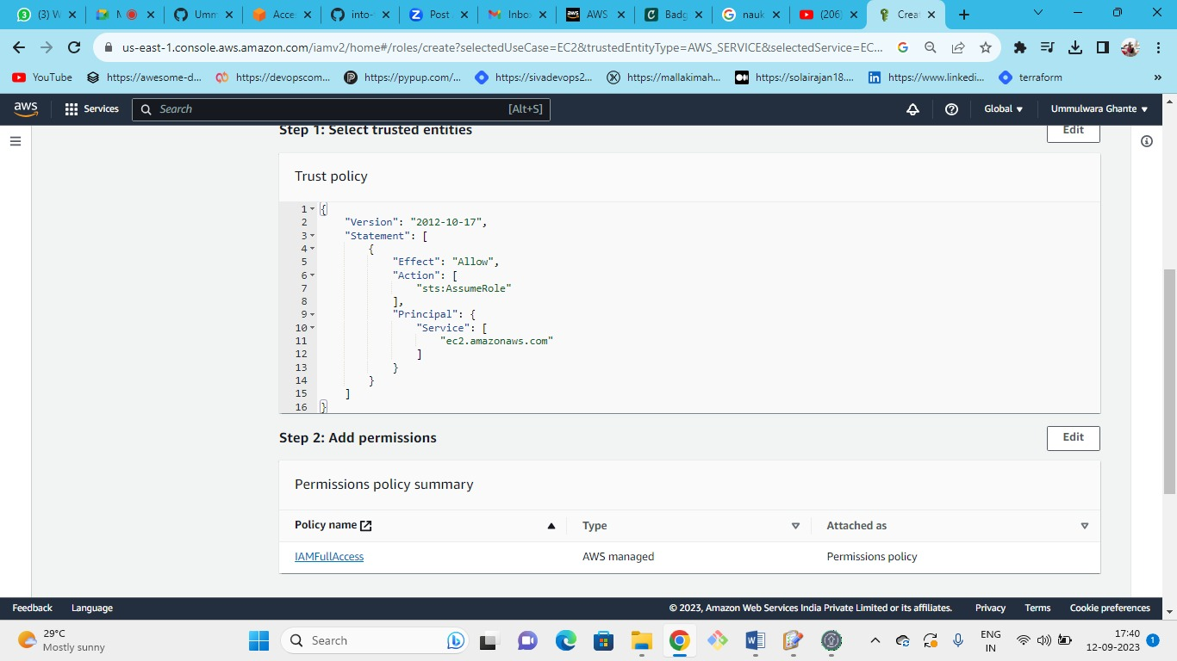

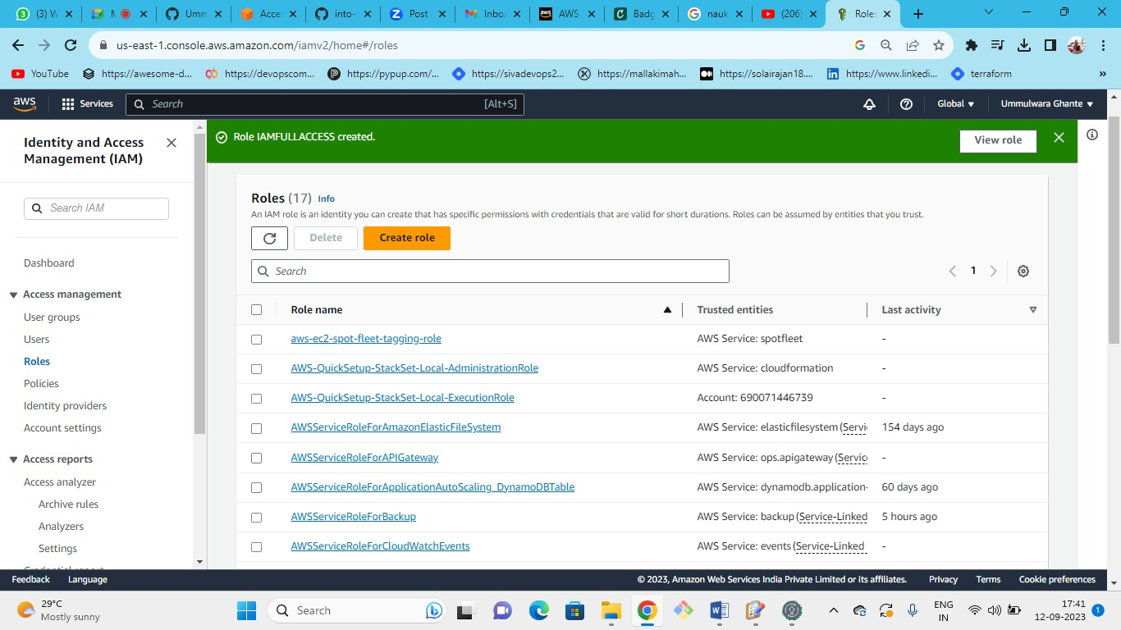

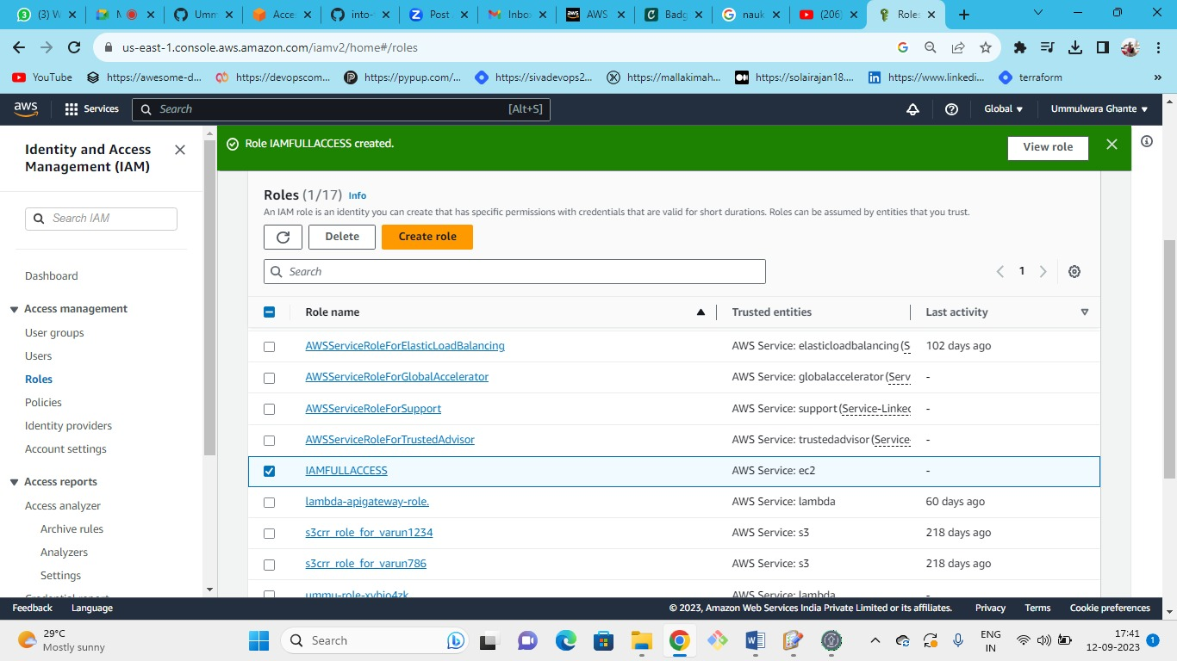

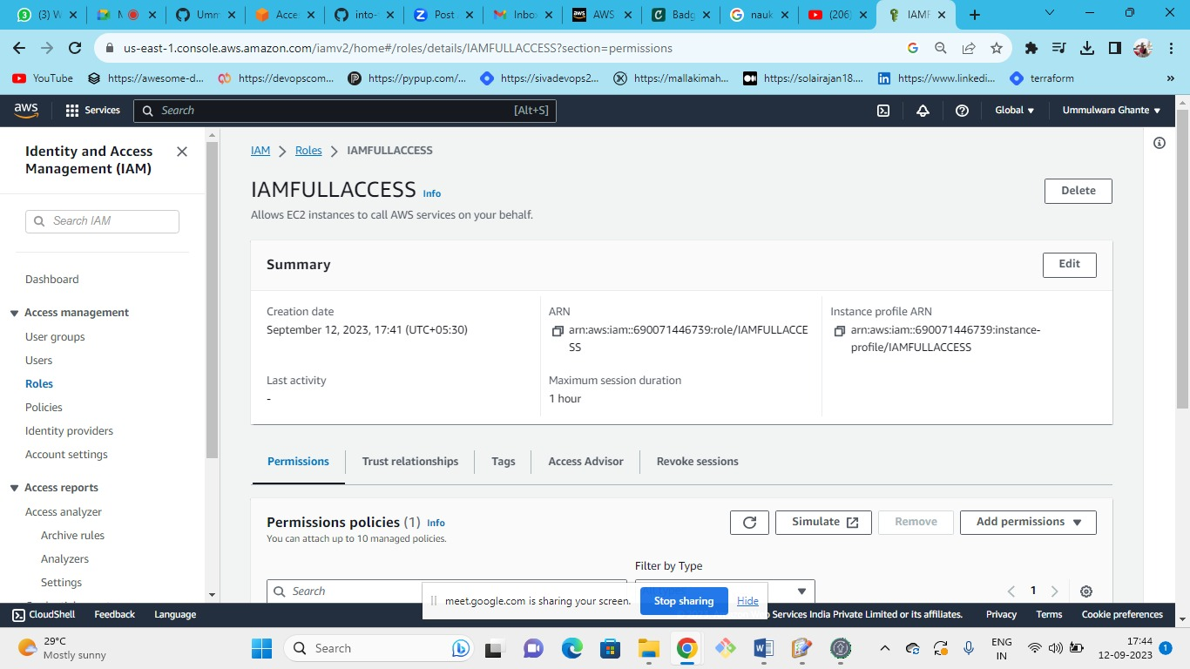

**Solution**

1. Go to AWS console -> IAM
2. Click in the left side menu on "Access Management" -> Roles
3. Click on "Create role"
4. Choose "AWS service" as the type of trusted entity and then choose "EC2" as a use case. Click on "Next"
5. In permissions page, check "IAMFullAccess" and click on "Next" until you get to "Review" page
6. In the "Review" page, give the role a name (e.g. IAMFullAcessEC2), provide a short description and click on "Create role"
7. aws iam list-roles will list all the roles in the account, including the one we've just created.

**AWS - Credential Report**

**Objectives**

1. Create/Download a credential report
2. Answer the following questions based on the report:
3. Are there users with MFA not activated?
4. Are there users with password enabled that didn't
5. Explain the use case for using the credential report

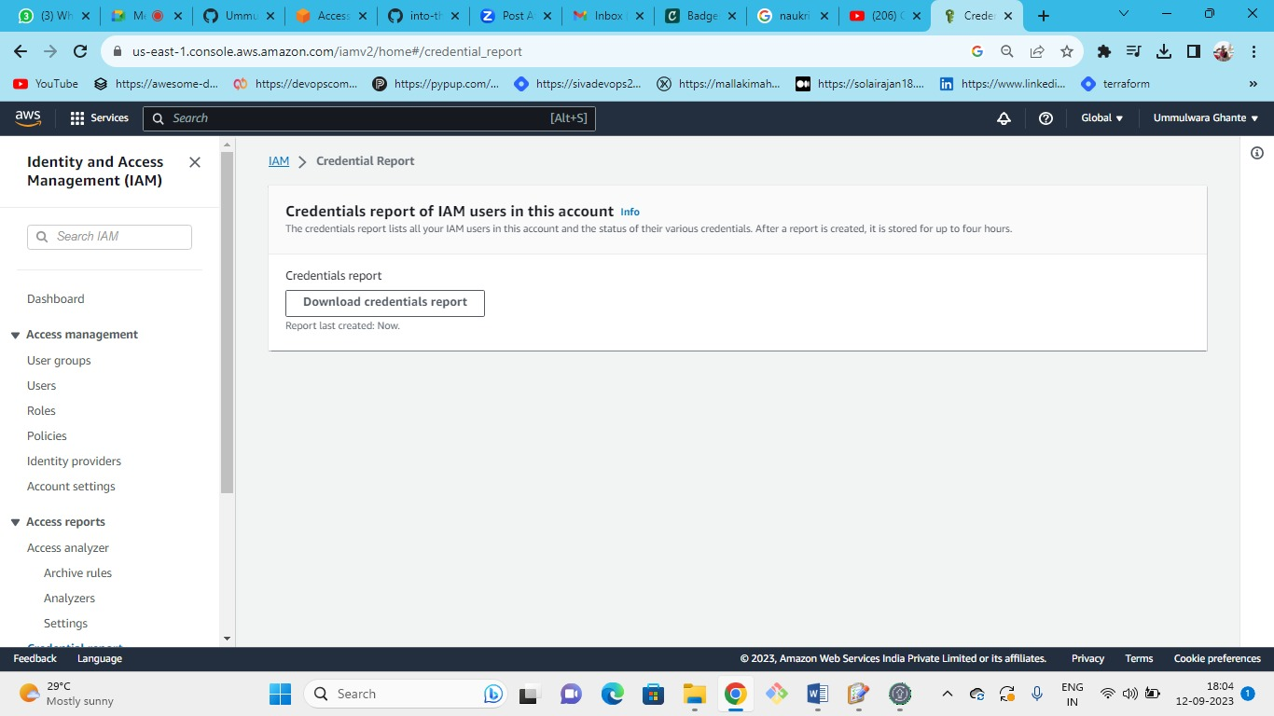

**Solution**

1. Go to the AWS IAM service
2. Under "Access Reports" click on "Credential report"
3. Click on "Download Report" and open it once it's downloaded
4. Answer the questions in this exercises by inspecting the report

The credential report is useful to identify whether there any users who need assistance or attention in regards to their security. For example a user who didn't change his password for a long time and didn't activate MFA.

**AWS IAM - Access Advisor**

**Objectives**

Go to the Access Advisor and answer the following questions regarding one of the users:

1. Are there services this user never accessed?
2. What was the last service the user has accessed?
3. What the Access Advisor is used/good for?

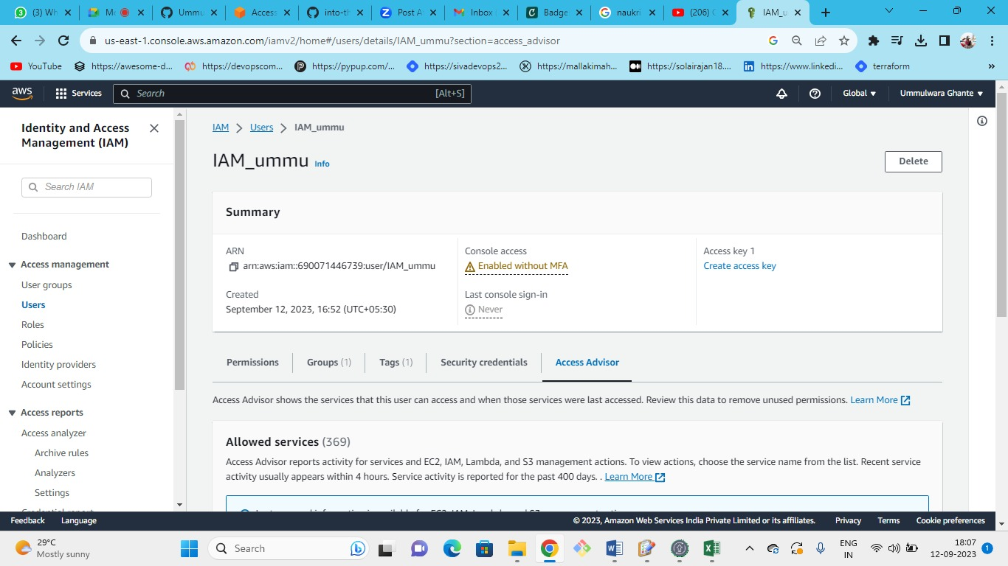

**Solution**

1. Go to AWS IAM service and click on "Users" under "Access Management"
2. Click on one of the users
3. Click on the "Access Advisor" tab
4. Check which service was last accessed and which was never accessed

Access Advisor can be good to evaluate whether there are services the user is not accessing (as in never or not frequently). This can be help in deciding whether some permissions should be revoked or modified.